# User Scenarios and Storyboards

1. Customer lives on the east side of Brisbane and wants 2 packages delivered on an express delivery. On the spot delivery services is in the work area and is able to perform the customer’s request. The client’s packages weigh 5Kg in total and would cost $6 delivery. The customer sets the order with full details including, address, postcode, name and card details to finalise the order. A driver is sent out to pick up the packages and receive a signature to approve the delivery. The driver then checks the packages in to the warehouse to be logged into the system and then is sent off to its intended destination.
2. A customer lives in Cairns and has placed a pickup from on the spot delivery but the service doesn’t reach that area so the customer is given a notice that this service is unavailable and is recommended to try another service.

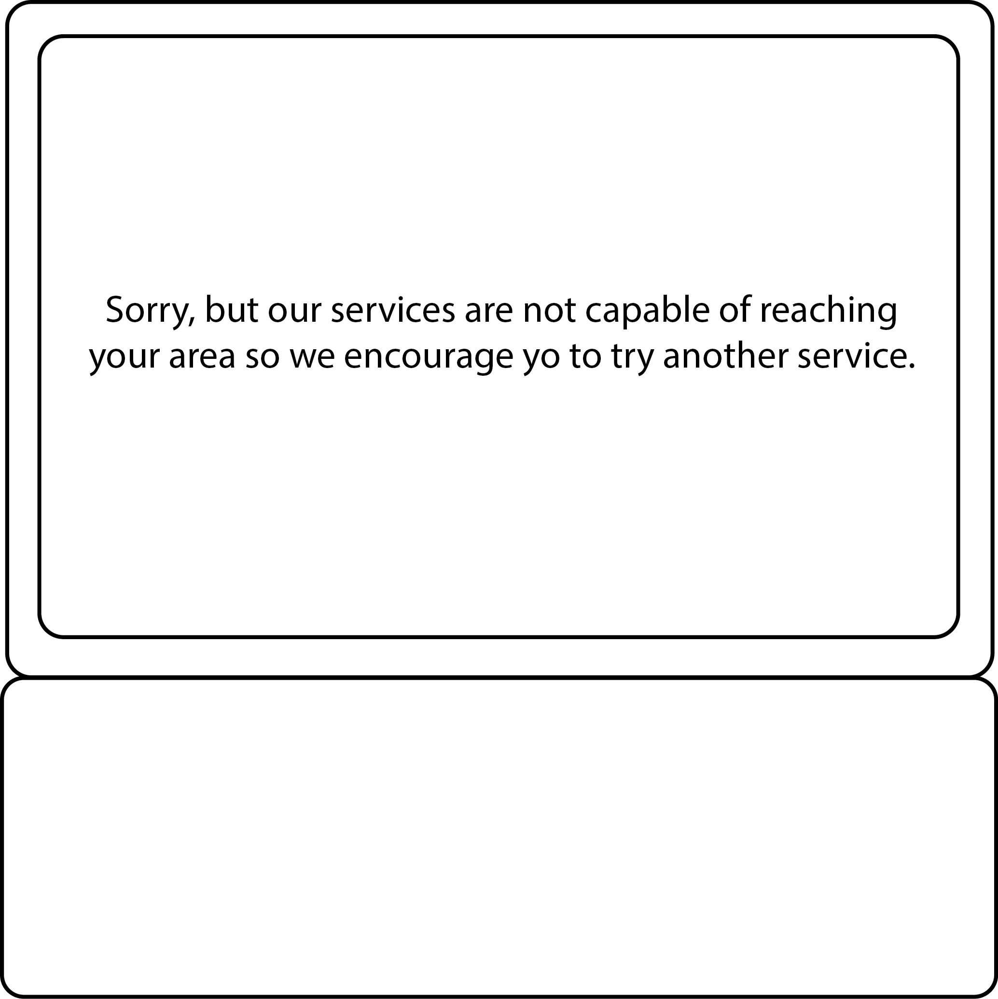

1. A customer’s package has reached the warehouse and isn’t checked in by the driver. The driver is alerted that this package wasn’t logged and is warned that it needs to be done. The driver then logs the package and the work flow continues.

|  |  |  |
| --- | --- | --- |
|  |  |  |

1. The customer database has found a double in emails for two different accounts and removes the new account to make sure that there are no recurring key details.

|  |  |  |  |
| --- | --- | --- | --- |
| Name | Email | Address | Postcode |
| Tom Jones | [email@email.com](mailto:email@email.com) | 123 One St. | 4111 |
| Tom Jones | email@email.com | 123 One St. | 4111 |
| Adam Joy | adamj@email.com | 32 Two Rd. | 4213 |

|  |  |  |  |
| --- | --- | --- | --- |
| Name | Email | Address | Postcode |
| Tom Jones | [email@email.com](mailto:email@email.com) | 123 One St. | 4111 |
| ~~Tom Jones~~ | ~~email@email.com~~ | ~~123 One St.~~ | ~~4111~~ |
| Adam Joy | adamj@email.com | 32 Two Rd. | 4213 |

|  |  |  |  |
| --- | --- | --- | --- |
| Name | Email | Address | Postcode |
| Tom Jones | [email@email.com](mailto:email@email.com) | 123 One St. | 4111 |
| Adam Joy | adamj@email.com | 32 Two Rd. | 4213 |